**TABLE OF CONTENTS**

1. Executive summary 2

2. Background to parties 2

2.1 the firstRand group 2

2.2 GHL Bank 4

3. transaction rationale 5

4. operating model 9

5. governance 10

6. Financials 10

7. CONCLUSION 11

# Executive summary

The acquisition of GHL Bank Limited (“GHL Bank”) and subsequent merging of First National Bank Ghana (“FNB Ghana”) and GHL Bank will effectively accelerate and complement the retail portion of FNB Ghana’s strategy, effectively adding a modest affluent client base and mortgage loan book.

On completion of the proposed acquisition, FirstRand Limited (“FirstRand”) intends for the operations of GHL Bank and FNB Ghana to continue on a “business as usual basis” in the short term, with the operations of GHL Bank to be merged as an operating business unit FNB Ghana, and the banking licence of GHL bank to be surrendered to Bank of Ghana (“BoG”).

Given the recent capital injection by FirstRand to FNB Ghana, the combined business will still meet the minimum capital required by BoG of GHS400 million. In the medium to long term, it is envisaged that significant synergies will be realised through the combination and rationalisation of the two businesses.

FirstRand has the capacity and willingness to deploy capital into growing the asset book of the combined business and towards diversifying the product and service offering in the future. As a principle, the group capitalises all entities on a standalone basis and will always ensure that its subsidiaries are adequately capitalised.

It is important to note that the interaction with GHL Bank thus far has been primarily focused on the fulfilment of the due diligence requirements. It is the desire of FirstRand that FNB Ghana and GHL Bank hold a strategy session, post the implementation of the intended transaction, with all management teams to draft a more detailed revised strategy for the combined businesses.

# Background to parties

# the firstRand group

FNB Ghana is a wholly-owned subsidiary of FirstRand Emerging Markets Africa Proprietary Limited (“FREMA”), which in turn is a wholly-owned subsidiary of FirstRand Limited. Listed on the Johannesburg Stock Exchange (JSE), FirstRand Limited is the largest financial institution in Africa by market capitalisation ZAR363 billion (as at 9 July 2019). In addition to South Africa, the FirstRand group operates in the United Kingdom, Guernsey, nine countries on the broader African continent and India. FirstRand Bank Limited, the Group’s 100% held primary cross-border banking entity, also has representative offices in Shanghai, China and Dubai, United Arab Emirates. An abridged view of the FirstRand corporate structure is noted in Figure 1.

**Figure 1** – Abridged FirstRand corporate structure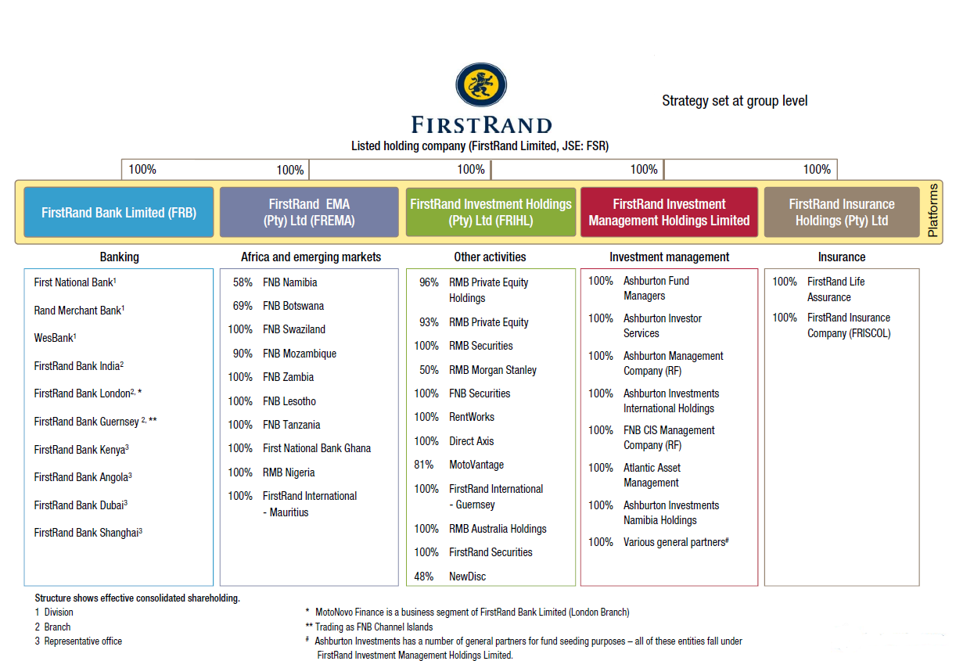

FirstRand group subsidiary FNB Ghana commenced operations in October 2015 and operates as a fully licensed bank under the supervision of the BoG.

FNB Ghana seeks to bank the commercial and corporate client ecosystem, effectively leveraging key commercial and corporate client relationships by referencing their commercial value chain and employees to penetrate these client segments by delivering a market differentiating service offering. The business case is predicated on a digitally-enabled commercial, corporate and investment banking led strategy, complemented by the upper retail (affluent) market segment (“CCIB-r”).

As at 31 December 2018, FNB Ghana had a loan book of approximately GHS85 million and total assets of approximately GHS640 million for the financial year ending on that date.

FirstRand group is proud of its “owner-manager” culture and believes that this approach to human capital of empowering and holding staff accountable is a core part of its sustainable competitive advantage. In line with this philosophy and to better distinguish the Group’s financial services offering in the minds of customers, the FirstRand group operates under multiple customer-facing brands that can span legal entities.

The FirstRand group’s approach to branding is noted in Figure 2.

**Figure 2** – FirstRand Group’s operating brands that span entities and jurisdictions

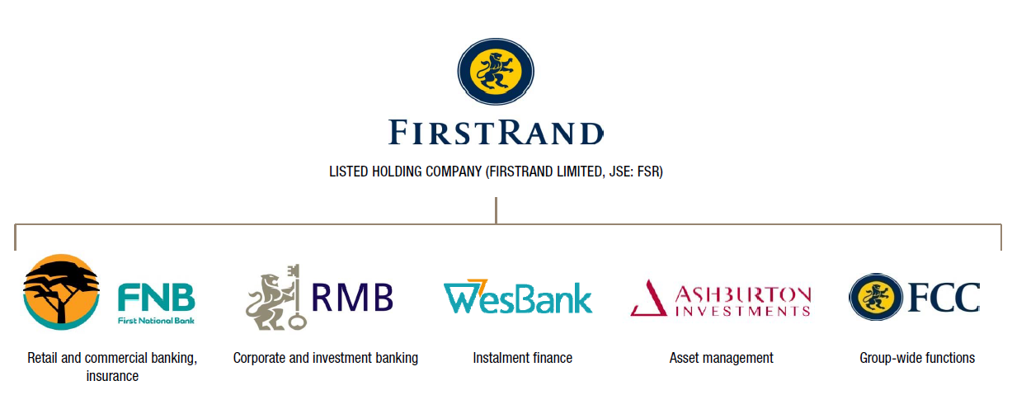

# GHL Bank

GHL Bank was established in 2006 as a home loans company and converted to a universal bank after obtaining a licence in 2017. The bank has a staff complement of 308 (161 of whom are permanent) with 5 ATMs and 4 branches in Ghana. The home loans business is well established, although the banking business is still sub-scale as capabilities are being built up, which is a key focus. At the core of GHL Bank’s banking strategy is its efficient business model, which has proven profitable and resilient to currency volatility.

Prior to its issuance of a commercial banking licence in December 2017, GHL Bank was a mortgage finance institution operating under BoG supervision as a non-bank financial institution. With more than 10 years experience in the mortgage industry, GHL Bank has grown to become one of the leading residential mortgage finance providers in Ghana, with an estimated market share of over 50%.

GHL Bank has a primary focus on the Ghanaian residential home buyer offering mortgages, including mortages for first time buyers, buy to let, equity release, refinance and home completion products, in addition to offering mortgages on Ghanaian properties to Ghanaians living abroad.

As at 31 December 2018, GHL Bank had a loan book of approximately GHS562 million, total assets of GHS689 million, and profit before tax of approximately GHS5 million for financial year ending on that date.

GHL Bank’s journey thus far is illustrated in Figure 3.

**Figure 3** – GHL Bank’s journey

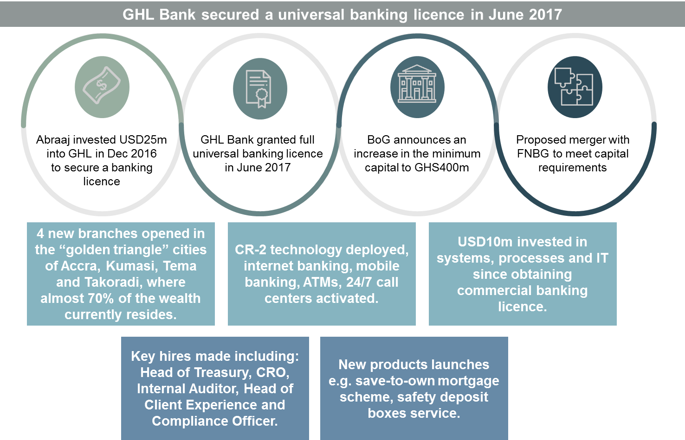

# transaction rationale

The FirstRand Group's current strategy is anchored to achieving a better diversified revenue profile from a segment, product and geographic perspective. FirstRand believes that successful execution of these diversification strategies will ensure it continues to deliver growth and sustainable superior returns for its shareholders. The rest of Africa forms an important pillar of this strategy and Ghana has been identified as a key growth market in this geography.

The GHL Bank management team have an impressive track record of building a profitable and return generative retail bank over the last ten years. Since converting to a bank in 2017, GHL Bank have invested in extending its capabilities to expand its retail banking services into transactional banking. GHL Bank’s future plans include expanding their client focus into SME and corporate banking. The combination of GHL Bank’s expertise in retail mortgage finance, coupled with the FNB Ghana’s CCIB and transactional banking expertise is expected to accelerate the strategies of both entities, bringing operational synergies and the benefits of improved scale to both. FirstRand believe that the combined entity will benefit from these identified synergies.

The acquisition of GHL Bank and subsequent merging of FNB Ghana and GHL Bank will result in a more efficient and scalable Ghanaian bank which should enable greater opportunities for customer growth and roll out of the CCIB-r bank strategy. GHL Bank holds a leading position in the mortgage lending market in Ghana which brings new customers and cross sell opportunities to the FNB Ghana ecosystem. In addition, GHL Bank is currently funded primarily by DFI funding, and given the FirstRand Group's South African balance sheet, there is opportunity to optimise this funding structure and extract synergies for the combined business.

FirstRand Group’s stated strategic direction for Ghana is to focus primarily on the CCIB profit pools and business opportunities where scale can be achieved more rapidly while at the same time developing a retail banking offering, leveraging the CCIB ecosystem. However, the Ghanaian market size is such that a CCIB profit pool on its own, is not sufficient to justify the GHS400 million investment and as such also requires a retail offering to augment CCIB. The retail opportunity is targeted at the affluent and premium segments of the market, leveraging digital channels and remote acquisition of clients at their workplaces (infrastructure light to accelerate the journey to retail profitability). Lending in retail has been focussed on unsecured credit to main-banked customers, with plans to roll out VAF in the short term and Mortgages planned for further in the future (as this product requires specific market expertise).

The combined business will retain the primary focus on CCIB clients, and the addition of a well-provided mortgage book will add much needed scale to retail, and significantly improve the overall return on invested capital and return on equity profile. The retail component of the FNB Ghana business case has always envisaged an acquisition as a possible means to scale quicker. FirstRand has been successful in developing retail businesses in those countries where significant acquisitions have been made (UK, Namibia, Botswana) rather than developing these on a greenfields basis.

The original strategic direction expected retail to be rolled out at a more cautious pace, given the deep investment required and the time to reach scale. The proposed acquisition of GHL fast-tracks the introduction of mortgages in the Ghana, it does so on the basis of significant in-country experience and expertise, in an area that forms part of the long-term strategy of FirstRand in Ghana.

The acceleration of FNB Ghana’s retail strategy is illustrated in Figure 4.

**Figure 4** – Retail strategy in Ghana

*Source*: FirstRand Group

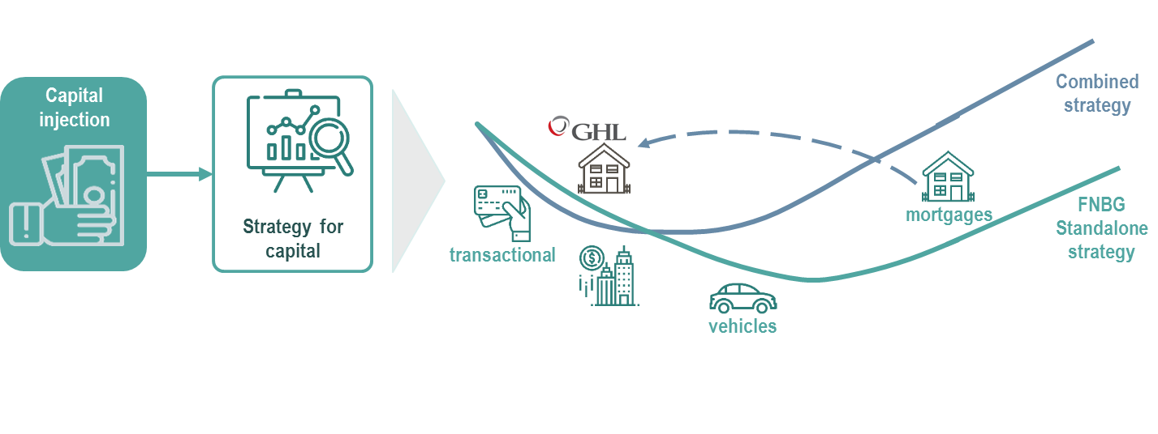

The GHL Bank business is attractive for several reasons, including:

* the acquisition offers a complementary product offering and the mortgage product is a core part of the retail offering in all the markets where FirstRand operates;
* GHL Bank has a strong management team and management has extensive knowledge of the market and mortgage lending. Their experience has been gained over difficult economic cycles and requires navigation of a legal system that is not always suited to efficient work-outs;
* there are synergies in terms of points of presence as GHL Bank has branches in Kumasi, Takoradi, Tema and Accra and these are complementary to the current FNB Ghana expansion strategy in the business case;
* significant potential cost synergies have been identified in merging the two operations;
* GHL Bank has a strong brand in the Ghanaian market and although it is a home loans brand, it has been able to attract a strong growth in liabilities since becoming a bank; and
* the transaction will allow FNB Ghana to gain market share as GHL Bank is a leading home loans provider in Ghana, with more than 50% of the total mortgage market. There is also opportunity to grow in this market as the mortgage market in Ghana is still nascent, with less than 10% of properties having mortgages.
  1. Strategic alignment
     1. GHL Bank existing products:
* retail mortgage lending products
* retail and SME transactional banking
* retail unsecured loans
* retail deposits and investments
* foreign currency
  + 1. FNB Ghana existing products:
* retail and SME transactional banking
* retail and SME unsecured loans
* retail and SME deposits and investments
* CCIB transactional including card acquiring
* CCIB secured and unsecured lending
* CCIB structured products
* CCIB global markets products
* foreign currency

The strategic alignment between FNB Ghana and GHL Bank is illustrated in Figure 5.

**Figure 5** – FNB Ghana and GHL Bank strategy

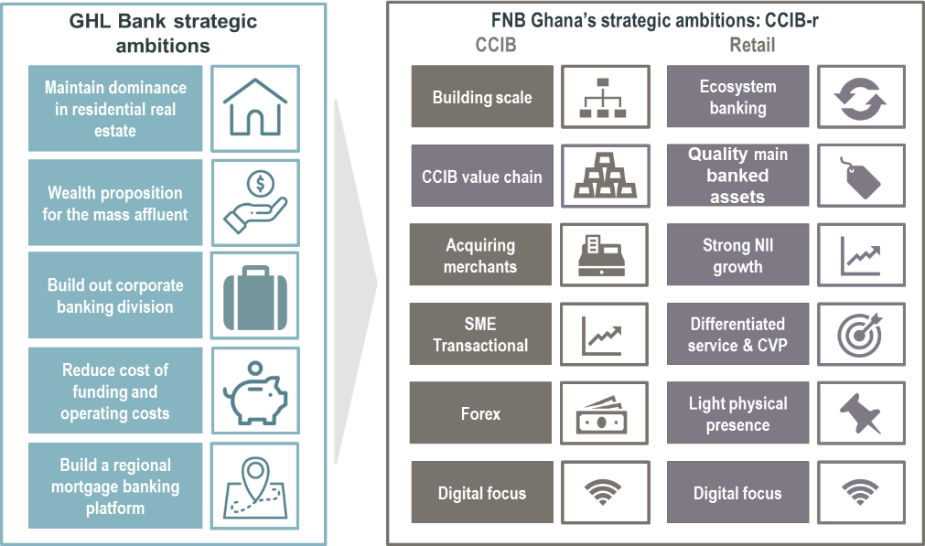

* 1. Combined business strategy

GHL Bank’s banking activities will fit into the retail portion of FirstRand group’s overall market strategy in Ghana, which is to focus on CCIB, backed by a strong retail business that provides funding and transactional activity.

The GHL Bank strategy is complementary to the FNB Ghana retail segment strategy with:

* premium target market;
* infrastructure light and digitally-enabled approach;
* complementary branch locations;
* attractive value propositions and rewards; and
* sales approach with tablet sales outside branches.

The FNB Ghana strategy for home loans was for a future launch to the upper end premium market in the medium to long term. Thus, the acquisition of GHL Bank will allow these products to be enabled for FNB Ghana on an expedited basis with significantly less operational risk.

It is FirstRand Group’s intention is to run the merged entity as a single business, with specific segmental focus on CCIB and retail (now incorporating home loans). Thus, the combined business strategy would remain CCIB-r however the addition of GHL Bank will naturally accelerate the achievement of critical mass in retail banking. GHL Bank’s existing segment focus is on affluent and wealthier clients, which complements the FNB Ghana’s affluent focus in retail. Both banks have been pursuing an infrastructure light strategy with a primary focus on digital banking. FNB Ghana has 7 bank branches, and GHL Bank has 4 branches. The physical location of the branches is complementary (GHL Bank’s branches are in locations that coincide with FNB Ghana’s plans for future branch expansion). In addition, the larger retail customer base will present opportunities for growth in Commercial and Corporate banking. The combined IT capabilities will continue to enable an agile and digitally led bank which is branch and ATM infrastructure light. The brands and market positioning of the two entities is similar with aligned customer value propositions.

# operating model

* 1. IT systems

The IT integration stream will focus on:

* the FirstRand group intends ultimately to operate the combined business by leveraging the GHL Bank system (T24) which will result in longer terms cost synergies, but investment will be required initially to enable the required CCIB functionality on T24, and to improve GHL Bank network security, application management, disaster recovery and access controls to meet FirstRand group standards. The FNB Ghana business will be migrated off Hogan and the integration team will spend significant effort in integrating the businesses to extract potential cost and revenue synergies; and
* an additional benefit of utilising GHL’s systems is that the same core banking system is used by eight other Ghanaian banks. When development is required to comply with changing Ghanaian regulations, this can be accommodated expeditiously through implementation partners, and FirstRand’s IT capacity will not be affected.

* 1. HR and staff communications

This integration stream will focus on:

* the FirstRand group recognises that the current GHL Bank management team and employees have a deep understanding of the mortgage lending business environment within which GHL Bank operates and have garnered industry-wide respect and recognition. Given this track record, and given the FirstRand group's philosophy of empowering management teams, it is of key importance to retain and appropriately incentivise the founders of GHL Bank and ensure that they are enabled to add maximum value in the merged group;
* the FirstRand group has indicated to the sellers that the acquisition will not be attractive to the FirstRand group without the full support of the GHL Bank management team and initial analysis has shown that there is a minimal overlap of staff functions. Where there is an overlap of resources for specific roles, a transparent interview, assessment and appointment process will ensure fairness to the staff of both GHL Bank and FNB Ghana;
* differences in corporate culture will be analysed and understood, and careful change management applied to encourage adoption of the FirstRand Promises (cultural principles) across the combined entity;
* the FirstRand group will continue to ensure strong financial and risk discipline and capacity in the combined business;
* clear and transparent communication to staff will be key throughout the integration process; and
* any staff displacements will need to be managed in accordance with the Labour Act, 2003 (Act 651).
  1. Operations and premises

This integration stream will focus on:

* business processes will be assessed, analysed and compared, and an aligned, “best of both” set of processes adopted for the combined entity; and
* premises and leases will be analysed and optimised. It is expected that savings in rental costs will be realised through the consolidation.
  1. Retail, Brand and client communications

This integration stream will focus on:

* client value propositions, products, channels and services will be analysed, overlaps understood and a revised, combined set of products relaunched to clients over time;
* analysis of both the GHL Bank and FNB Ghana brands will be undertaken, client views sought, and a future brand strategy for the combined entity determined; and
* clear and transparent communication to clients will be key throughout the integration process.
  1. Credit

The credit integration stream will focus on:

* all aspects of credit policy, pricing, practice and procedures will be analysed and compared between the two entities, and a revised consolidated set of policies and practices will be implemented that fall within the FirstRand group credit risk appetite, credit policy framework and performance measurement framework;
* a full review of credit processes across the full credit lifecycle will be undertaken, and an aligned best of breed set of processes applied to the combined entity; and
* provision calculations and related regulatory reporting to be compared between the two entities and reviewed against IFRS 9 principles.
  1. Finance

The finance integration stream will focus on:

* finalise interim period (until systems integration is finalised) and proposed final team structures (following integration) and in conjunction with HR;
* financial control:
  + deploying all financial related frameworks of the FirstRand group, in particular, delegated mandate of authority, revision of signing authority, procurement processes, balance sheet verification, suspense account management; and
  + implement FirstRand’s Account Management Reconciliation Framework (“ARMF”) and balance sheet substantiation steering committees.
* financial structure:
  + amend T24 to reflect FirstRand required management structures:
    - business units (i.e. FCC, CIB, Retail, Commercial, GTSY) (in collaboration with business and systems architecture teams);
    - business divisions (i.e. CB); and
    - business sub-divisions (i.e. TWC).
* financial systems:
  + integration of statutory reporting into the FirstRand group’s financial reporting and consolidation system (HFM);
  + integration of management reporting into FirstRand systems (Essbase, etc);
  + integration with regulatory interface (BA reporting and MBK reporting); and
  + deployment of funds transfer pricing methodology (in conjunction with treasury).
* Financial reporting:
  + consolidated financial reporting (in conjunction with FirstRand) (interim and final structure);
  + Consolidated management reporting (in conjunction with FirstRand) (interim and final structure).
  + Consolidated regulatory reporting (interim build-out of consolidated results - initially from two different systems) to BoG and SARB.
  1. Treasury

The treasury integration stream will focus on:

* governance:
  + regularisation all prudential requirements; and
  + alignment of treasury management policies and procedures to the FirstRand group standards.
* fnding:
  + restructure of all secured funding to unsecured; and
  + recall bond issuances.
* process:
  + listing and rationalisation of all bank accounts (combined entity); and
  + rationalisation of accountability on signing responsibility on bank accounts
* platform:
  + review of system against Treasury management requirements.
* people:
  + treasury organisational design; and
  + review of current people against organizational design requirements
  1. Legal

The legal integration stream will focus on:

* the group legal risk frameworks and governance processes will be implemented, and their application aligned with FNB Ghana and the FirstRand group;
* any legal risks identified during the due diligence process will specifically be attended to; and
* in due course legal processes and documentation will be aligned to FNB Ghana and group standards.
  1. Risk

The risk integration stream will focus on:

* governance structures in support of the business (risk and compliance);
* alignment of risk frameworks, policies and standards in accordance with the FirstRand group;
* assessment of completeness of risk metrics to the FirstRand group standards in current risk reporting output;
* completing skills assessment so as to assess opportunities for integration into FNB Ghana risk team;
* focus on operation of key controls and proper working of the controls (suspense accounts, internal fraud, cybercrime);
* assessment of risk technology in support of risk reporting and opportunities for scaled, integrated solutions to support the combined entity; and
* a review of the risk project programme and status of delivery.
  1. Compliance

The compliance integration stream will focus on:

* alignment of compliance frameworks, policies and standards in accordance with the FirstRand group;
* assessment of completeness of AML and regulatory risk universe risk metrics to the FirstRand group standards in current risk reporting output;
* completing skills assessment of compliance team so as to assess opportunities for integration into FNB Ghana compliance team;
* focus on operationalisation of KYC on-boarding process, status of KYC compliance, AML measures (STR, threshold reporting and sanction screening at a minimum);
* assessment of compliance (financial crime) technology in support of risk reporting and opportunities for scaled solutions across the combined entity; and
* a review of the compliance project programme and status of delivery.
  1. Other stakeholders’ communications

This integration stream will focus on:

* clear and transparent communication to stakeholders other than staff and clients will be key throughout the integration process. These other stakeholders include but are not limited to regulators, shareholder representatives and the media.

# governance

* 1. The Board of Directors of GHL Bank

FirstRand proposes the following changes to the structure of the Board for the approval of the BoG following the effective date of the proposed transaction:

[TBU once established]

# Financials

* 1. Financial projections

The financial projects set out below are based on the following assumptions:

1. All GHL Bank financial projections have been generated by GHL Bank management’s forecasts with an overlay of macroeconomic and industry forecasts.
2. The financial projections for FNB Ghana are per the most recent approved budget of this business unit.
3. The combined forecasts assume that the business operates as the minimum capital requirement which is the higher of GHS400m minimum paid up capital or 16% CAR.

|  |  |  |  |  |
| --- | --- | --- | --- | --- |
| **Assumptions** | **2019** | **2020** | **2021** | **Comment on assumptions** |
| **Macroeconomic assumptions** |  |  |  |  |
| Real inflation | 9.0% | 8.5% | 7.5% | Based on FirstRand’s houseview |
| GDP growth | 6.8% | 5.8% | 5.4% | Based on FirstRand’s houseview |
| Cost inflation | 12.6% | 11.4% | 10.3% | Based on FNB Ghana assumptions |
| Tax rate | 25.0% | 25.0% | 25.0% | Unchanged from current tax rate |
| National stability fund tax rate | 5.0% | - | - | Suspended from end 2019 |
| **Balance sheet** |  |  |  |  |
| Loan growth | 10.0% | 10.0% | 10.0% | Advances growth in line with FSR risk framework |
| Deposit growth | 100.0% | 75.0% | 50.0% | Current 6 month run rate = 197% |
| Other assets and liabilities | 15.8% | 14.3% | 12.9% | Real inflation plus GDP growth |
| **Income statement** |  |  |  |  |
| Non-interest revenue growth | 25.0% | 25.0% | 25.0% | Includes fees and foreign exchange gains and losses |
| USD loan advance rate | 13.0% | 13.0% | 13.0% | Current average USD loan rate |
| Percentage of USD deposits | 25.0% | 25.0% | 25.0% | Strategy to reduce reliance on USD deposits |
| Funding cost on GHS deposits | 6.0% | 6.0% | 6.0% | In line with FNB Ghana assumptions |
| Return on GHS t-bills | 13.4% | 12.4% | 12.4% | In line with FNB Ghana assumptions |
| Funding cost on USD deposits | 0.9% | 0.9% | 0.9% | In line with FNB Ghana assumptions |
| Return on USD t-bills | 2.5% | 2.5% | 2.5% | In line with FNB Ghana assumptions |
| DFI funding cost | 7.7% | 7.7% | 7.7% | Current average funding cost |
| Credit loss ratio | 2.0% | 2.0% | 2.0% | In line with FSR framework |
| Expense growth | 12.6% | 11.4% | 10.3% | In line with cost inflation assumptions |
| **Expected synergies/costs** |  |  |  |  |
| Cost savings (GHS’000) | 5 000 | 14 990 | 10 326 | Various cost synergies in combined entity |
| IT related costs (GHS’000) | (42 713) | (11 798) | (7673) | Development required to move to T24 |
| Funding cost benefit (%) | 2.2% | 2.2% | 2.2% | FSR credit benefit |

**Financial model output**

|  |  |  |  |  |  |
| --- | --- | --- | --- | --- | --- |
| **Income statement** | **Standalone** | | **Combined FNB Ghana and GHL Bank** | | |
|  | **FNB Ghana** | **GHL Bank** |  |  |  |
| **GHS (‘000)** | **Dec-18** | **Dec-18** | **Dec-19** | **Dec-20** | **Dec-21** |
| Gross interest income | 34 124 | 79 383 | 170 906 | 236 317 | 338 869 |
| Interest expense | (12 398) | (27 260) | (49 467) | (76 386) | (112 402) |
| **Net interest income** | **21 726** | **52 124** | **121 439** | **159 931** | **226 468** |
| Impairments | (4 898) |  | (21 240) | (23 766) | (30 182) |
| Non-interest revenue | 26 424 | 20 343 | 37 340 | 52 714 | 72 723 |
| Operating expenses | (80 967) | (64 334) | (192 844) | (174 100) | (194 097) |
| **Profit before tax** | **(37 714)** | **8 133** | **(55 305)** | **14 780** | **74 912** |
| Tax | -- | (3 554) | -- | (3 695) | (9 039) |
| **Profit after tax** | **(37 714)** | **4 579** | **(55 305)** | **11 085** | **65 872** |

|  |  |  |  |  |  |
| --- | --- | --- | --- | --- | --- |
| **Balance sheet** | **Standalone** | | **Combined FNB Ghana and GHL Bank** | | |
|  | **FNB Ghana** | **GHL Bank** |  |  |  |
| **GHS (‘000)** | **Dec-18** | **Dec-18** | **Dec-19** | **Dec-20** | **Dec-21** |
| Cash and cash equivalents | 174 489 | 25 338 | 93 867 | 136 496 | 277 324 |
| Investment securities | 296 129 | 43 750 | 387 887 | 453 068 | 556 695 |
| Net loans and advances | 84 342 | 561 648 | 825 676 | 1 248 933 | 1 621 265 |
| **Total assets** | **638 184** | **686 345** | **1 415 043** | **1 959 383** | **2 590 674** |
| Deposits | 182 824 | 94 842 | 539 444 | 890 631 | 1 340 947 |
| Borrowings | -- | 339 115 | 387 023 | 565 594 | 704 338 |
| **Total Liabilities** | **208 488** | **474 266** | **993 567** | **1 532 364** | **2 130 719** |
| **Equity** | **429 696** | **212 079** | **421 476** | **427 018** | **459 955** |

|  |  |  |  |  |  |
| --- | --- | --- | --- | --- | --- |
| **Key ratios** | **Standalone** | | **Combined FNB Ghana and GHL Bank** | | |
|  | **FNB Ghana** | **GHL Bank** |  |  |  |
|  | **Dec-18** | **Dec-18** | **Dec-19** | **Dec-20** | **Dec-21** |
| ROE | (8.8%) | 3% | (10.4%) | 2.6% | 14.9% |
| ROA | (5.9%) | 1% | (4.0%) | 0.7% | 2.9% |
| CET1 % | 180% | 39% | 36% | 27% | 20% |
| Total capital % | 180% | 39% | 36% | 27% | 20% |
| Credit loss ratio | 5% | n.a. | 2% | 2% | 2% |
| Cost to income ratio | 168% | 89% | 121% | 82% | 65% |
| Loan/retail deposits | 46% | 592% | 89% | 86% | 79% |
| Liquid assets/total assets | 74% | 10% | 37% | 32% | 31% |

Based on initial discussions with the combined management team, there is scope to improve these forecasts if the following targets are achieved for the business:

|  |  |  |  |  |
| --- | --- | --- | --- | --- |
| **Upside case** | **2019** | **2020** | **2021** | **Comment on assumptions** |
| **Growth assumptions** |  |  |  |  |
| Deposit growth | 100% | 100% | 100% | Expect strong deposit growth given low base, and focus on strategy |
| Non-interest revenue growth | 25% | 35% | 35% | Strategy to increase non-interest revenue |
| Percentage of USD deposit | 50% | 50% | 50% | Strong deposit growth would correlate to higher percentage USD deposits |
| Funding cost on GHS deposits | 8% | 8% | 8% | Strong deposit growth would correlate to higher GHS deposit rate |
| Funding cost on USD deposits | 1.5% | 1.5% | 1.5% | Strong deposit growth would correlate to higher USD deposit rate |

By applying the above assumptions, the combined entity would achieve a ROE of 15.3% by 2021.

# CONCLUSION

FirstRand believe that the proposed acquisition of GHL Bank by FNB Ghana and the proposed merger between FNB Ghana and GHL Bank will result in FNB Ghana acquiring a skilled and experienced management team, which, in turn, will further strengthen its CCIB, retail and mortgage banking capabilities. In addition, the proposed acquisition will also enable expansion and diversification of business activities and product offerings, in a responsible manner, to the benefit of clients in Ghana and in areas where our existing operations in Ghana are currently either not represented at all or not sufficiently represented.